Skill search No / blank / blank / blank = no results

Skill search Yes / blank / blank / blank = no results

Limit size of ALL user entry fields

Limit size of FirstName field

Limit size of LastName field

Limit size of EmailAddress field

Limit size of newSkillText field

Change canonical skills name field to Skill

Limit size of Skill / (name) field

Change “Beach Only” to “Beach Status”

Add beach status = “Any” to BeachOnly / Beach Status” search field

Remove email Address search field from AE screen

When AE logs on, the home screen should display all consultants with all skills.

Search = status = all, name = blank

All registered consultants, and all skills should be displayed

This should **not** be the AE home screen

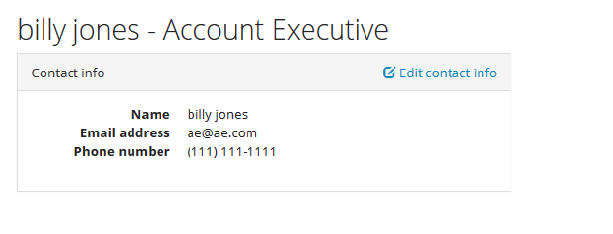

This should be the AE home screen

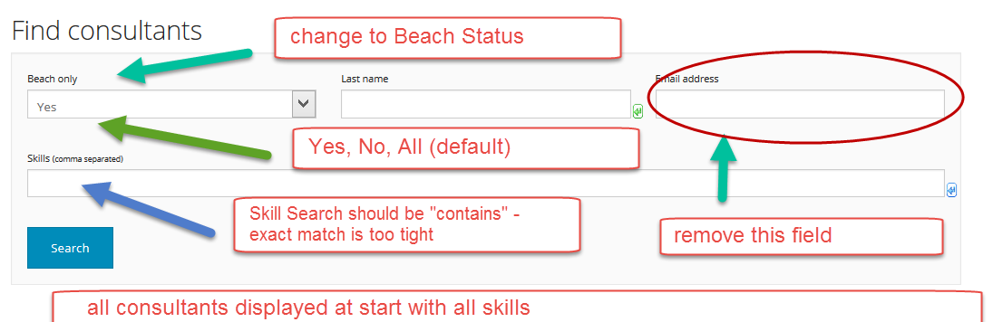

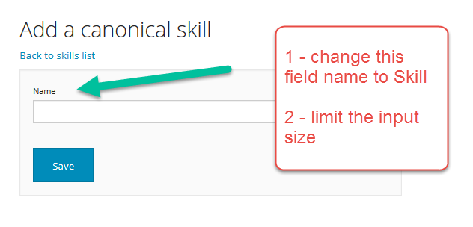

Cannot add skill

